**Check Year is Leap or not**

This document will explain you how to check whether the year is leap year or not.

* **Leap year –** It is a year which has 366 days. The [extra](https://www.collinsdictionary.com/dictionary/english/extra_1) day is 29th of February. Leap year comes after every four years.

**Step 1:** Open **LeapYearorNot.zappy** file.

**Automation**:

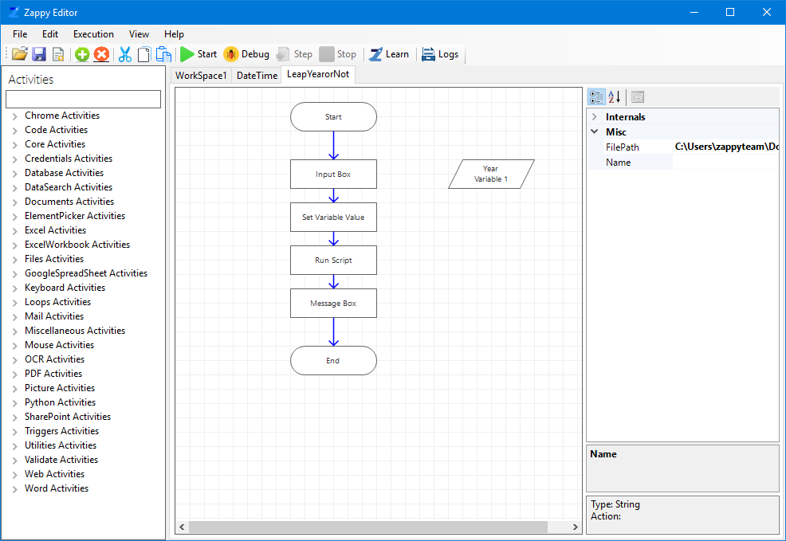

**Step 2:** Click on **Run Script** action and write the Script.

It will check if the input year is leap or not. **Script** is shown in below picture**.**

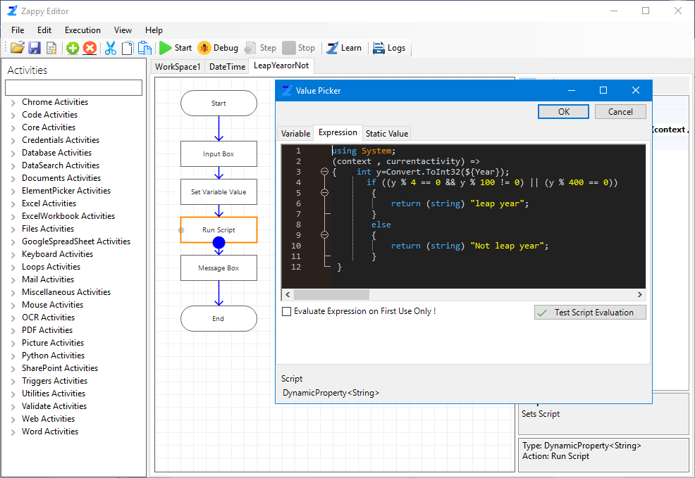

**Step 3:** Click on **Start**.

**Step 4:** Enter year in pop up Input Box, click **Ok**.

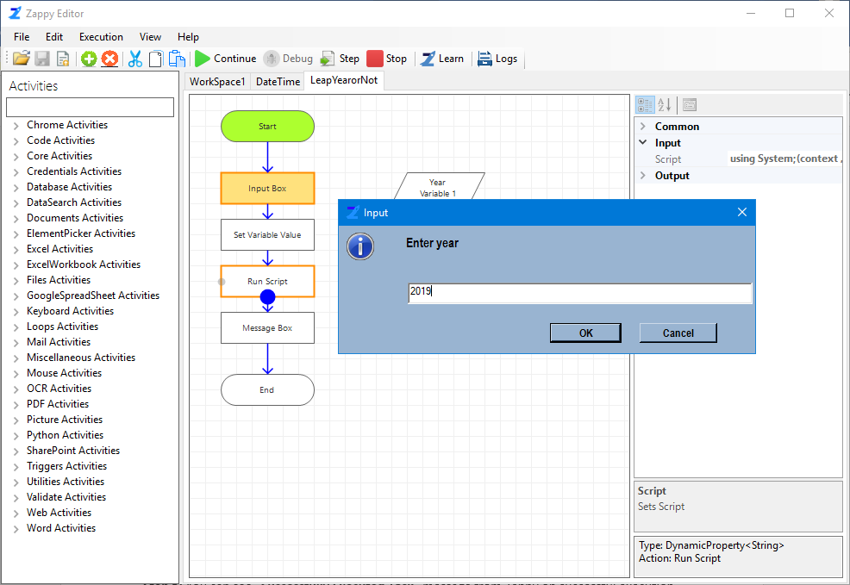

**Output:** Result will be displayed in the **Message Box** as shown below,

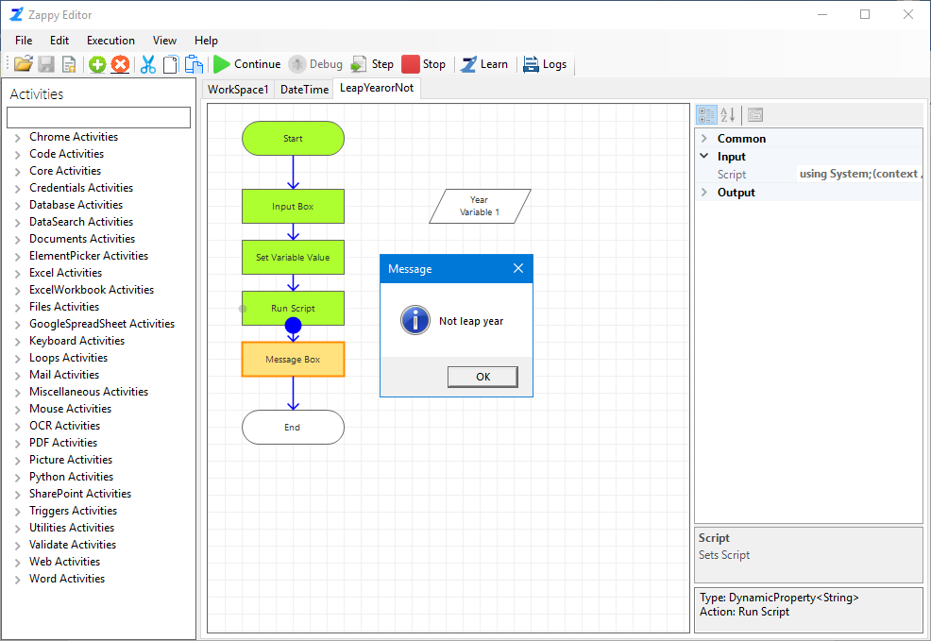

**Likewise, we can write any C# code in Run Script action and execute it.**